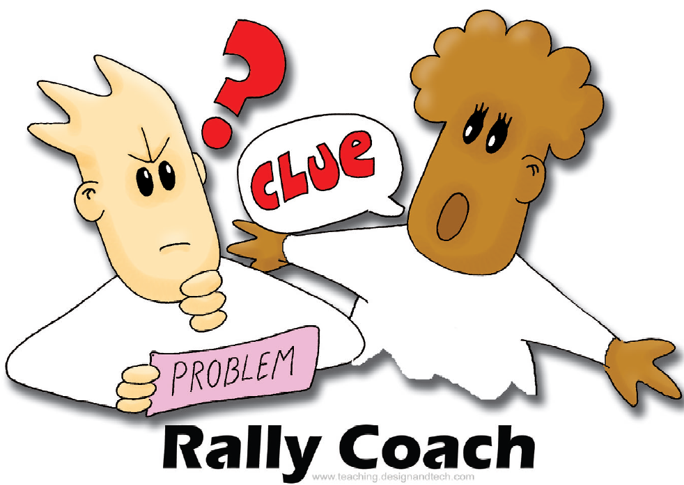
Rally Coach

How does a ‘Rally Coach’ work?
Partners take turns, one solving a problem while the other coaches.

A

$$4|\overline{\text{92}}$$

$$8|\overline{\text{96}}$$

$$3|\overline{\text{81}}$$

$$5|\overline{\text{820}}$$

$$6|\overline{\text{642}}$$

$$4|\overline{\text{892}}$$

$$7|\overline{\text{9506}}$$

$$3|\overline{\text{7023}}$$

$$6|\overline{\text{81252}}$$
B

$$6|\overline{\text{84}}$$

$$4|\overline{\text{76}}$$

$$6|\overline{\text{96}}$$

$$4|\overline{\text{852}}$$

$$3|\overline{\text{948}}$$

$$3|\overline{\text{948}}$$

$$9|\overline{\text{9072}}$$

$$5|\overline{\text{8420}}$$

$$4|\overline{\text{76012}}$$

