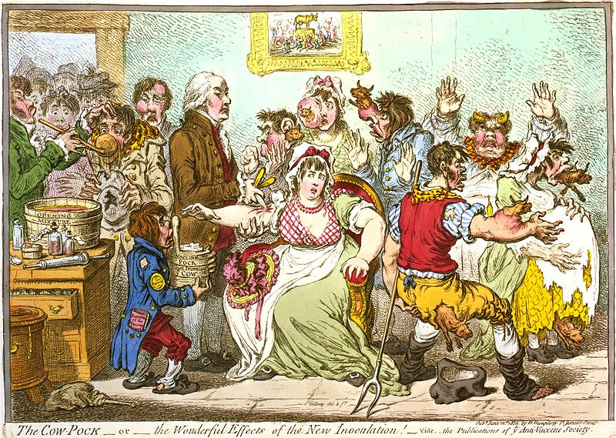
What’s the Story?

- What’s the story?

- What’s the other story?

- How do you know the story?

- Why know/tell the story?

- Where’s the power in the story?

